### BRAINSTALK – A WEB APPLICATION FOR E-LEARNING MANAGEMENT

|  |  |
| --- | --- |
| **S.no** | **Contents** |
| 1. | Contents |
| 2. | Problem Statement |
| 3. | Introduction |
| 4. | Abstract |
| 5. | Objective |
| 6. | Functionalities |
| 7. | Software & Hardware requirements |
| 8. | Methodology |
| 9. | Conclusion |

# Problem Statement

With the advent in technology and with the perpetual increase in the strength of the students and the number of departments in the educational institutions, it is laborious to exchange the study materials between the students and the faculties.

The main objective of the E-Learning is to help the students get over the traditional methods of learning and make them accustomed to the internet where the notes for their respective subjects are easily available. It provides an automation procedure of studying the notes online. The implementation of this project helps both the students and the teachers.

This project not only helps to facilitate easier access to the online academic activities for the students but also helps cutting down on expenditure for the universities as well. Students and Universities alike spend a considerable amount of money on infrastructure and different physical activities which can be lowered with the help of E-Learning platform.

# Introduction

The ‘BrainStalk’ ‘E-Learning Management Platform’ is developed to overcome the challenges Institutions are face in transforming from the ‘Traditional (Manual) Education System or weak online systems to a complete E-Learning System. Moreover our platform will be designed for the particular needs of the institutions. Different institutions will be aple to modify the platform with just few click on the basis of their needs.



# Abstract

The purpose of ‘BrainStalk’ E-Learning Management Platform is to help institutions to achieve the goals of E-Learning and eliminate the traditional education system or the hardships they face due to lack of complete online solution for teaching which involves different manual operations and a whole lot of burden due to spreaded system.

‘BrainStalk’, as described above, will lead to interactive, secure, reliable and one of a kind E-Learning Management Platform. ‘BrainStalk’ will help students to concentrate on learning and Teachers to concentrate on teaching instead of worrying about keeping different students records like Attend, Scores, Timetable, Assignments and a lot more.

**Objective**

The aim is to develop a system which will not only help in providing a better way of online education but also provide a Interactive and Attractive platform. Because, many platform’s lacks behind in these two qualities which lead to their termination or desertion. ‘BrainStalk’ will help students to concentrate on learning and Teachers to concentrate on teaching instead of worrying about keeping different essential academic records as they will be automatically generated.



# Functionalities

* Video Lectures
* Live Classes
* Quizzes
* Exams
* Practical/Lab Sessions
* Blogs
  + Professor’s Views
  + Placement Guide’s Etc.
* Forum
* Course Materials
  + Notes in Ppt’s or PDF format
  + Syllabus
  + Assignments Etc.
* Attendance
* Timetable
* Blogs
  + Professor’s Views
  + Placement Guide’s Etc.
* Notification Board
* Administrative Access to modify platform with just few clicks. and many more.

## SOFTWARE & HARDWARE REQUIREMENTS

**Hardware Requirements:**

* Personal Computer
* Laptop

### Languages, Frameworks:

* JavaScript
* EJS
* CSS
* React.Js
* Bootstrap

## Server:

* Node.Js

### Software’s / IDE’S /Text Editors:

* Node.js
* MongoDB
* MongoDB Compass
* Visual Studio Code
* Web Browser

Page 7

# Methodology

The front-end work is done with the help of our knowledge related to EJS/ React.js, Javascript, CSS, and Bootstrap. The back-end work is done with the help of Node.JS, Express.JS & MongoDB. We used the localhost NODE server for now and later we will deploy the portal on globalhost. The proper database is created to record every information and will make it sure to follow a proper privacy policy as everything is stored in Cloud (MONGODB ATLAS).



**Conclusion**

This project should prove to be a powerful package in satisfying all the requirements of an institution. The objective behind this project is to develop a system which will not only help in providing a better way of online education but also provide a Interactive and Attractive platform and we believe that on completion of this project, the objective will be fulfilled successfully.

**Result Ans Output**

* **Faculty/Teacher’s Portal**

1. **Home Page**

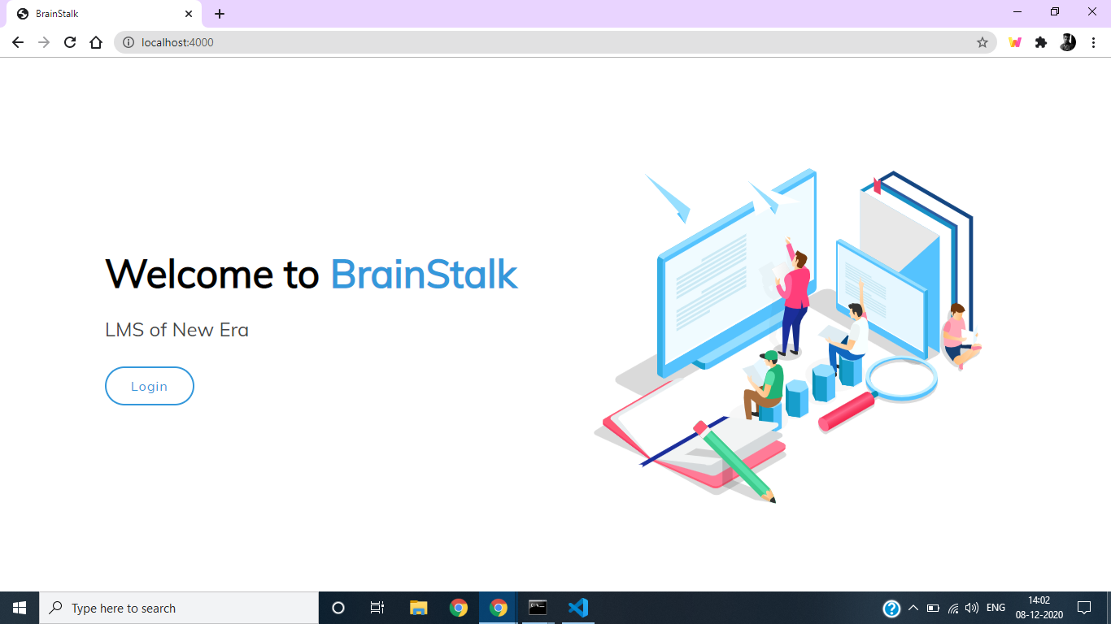

1. **Registration Page**

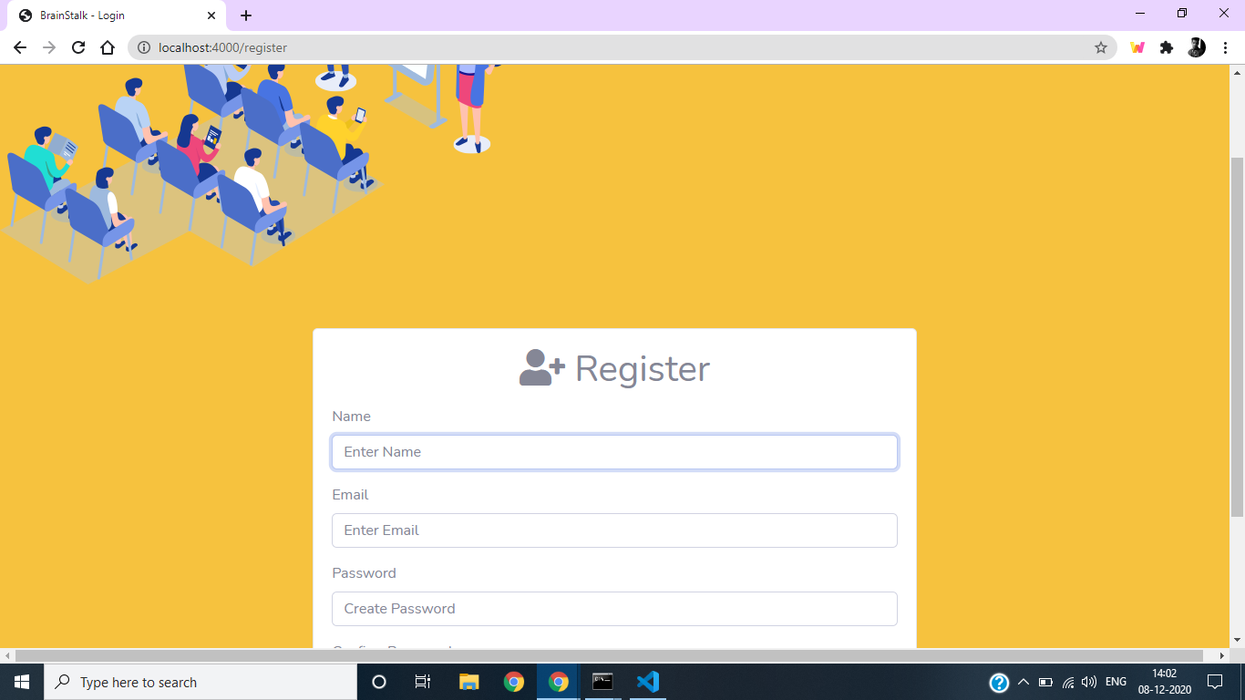

1. **Login Page**

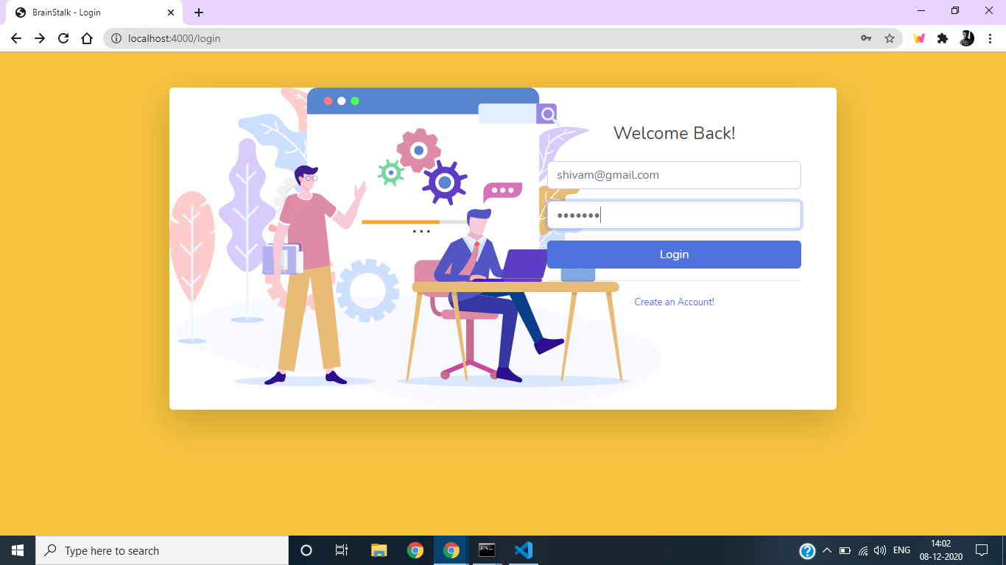

1. **Faculty Dashboard**

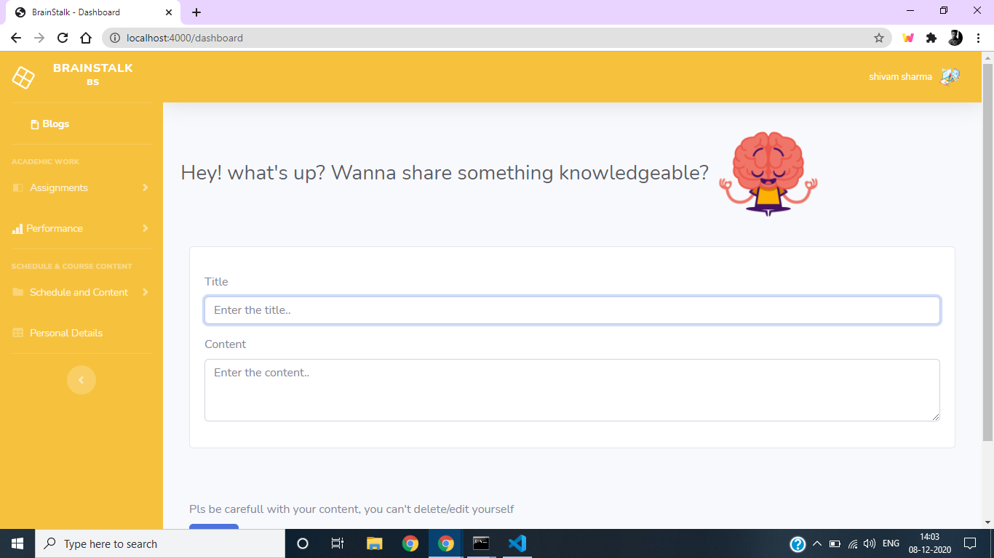

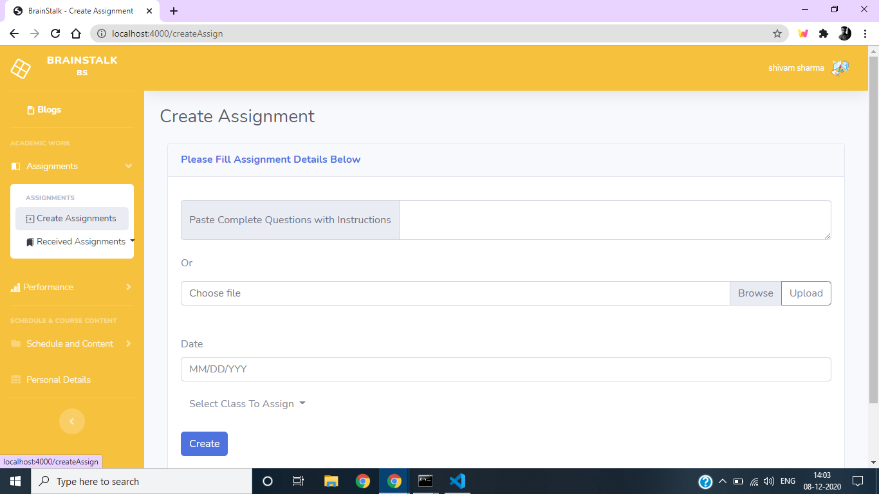

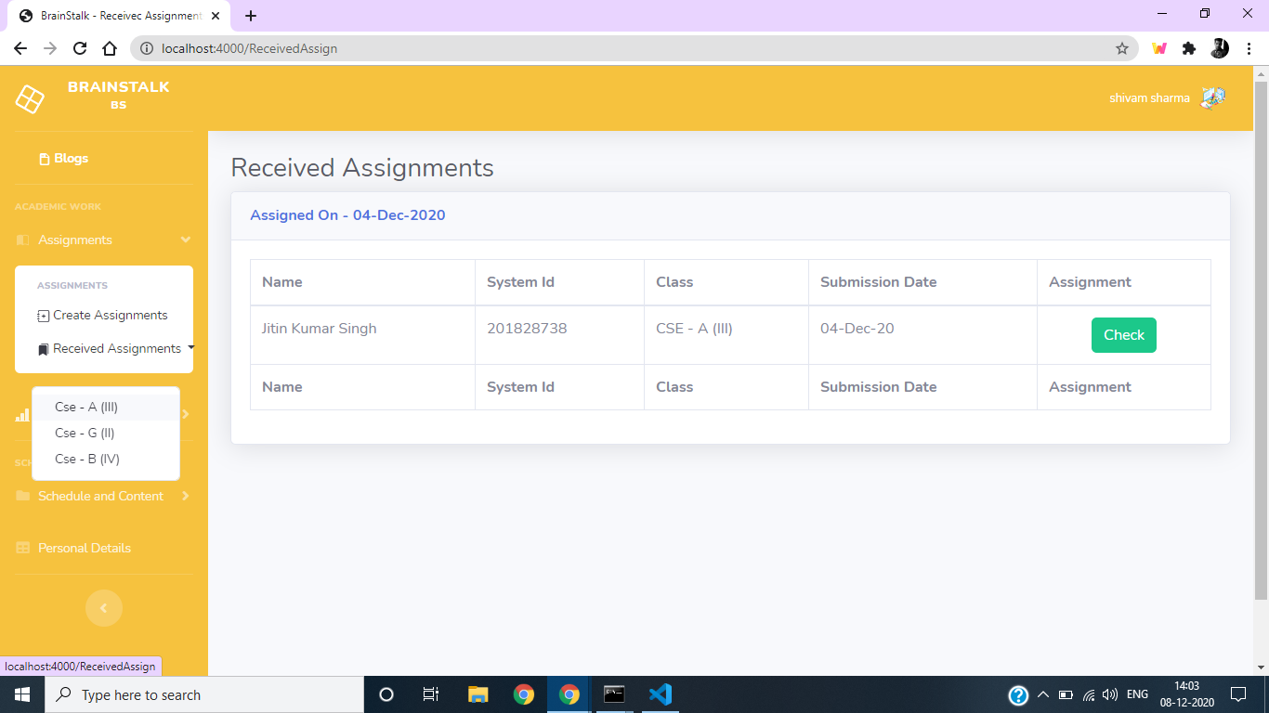

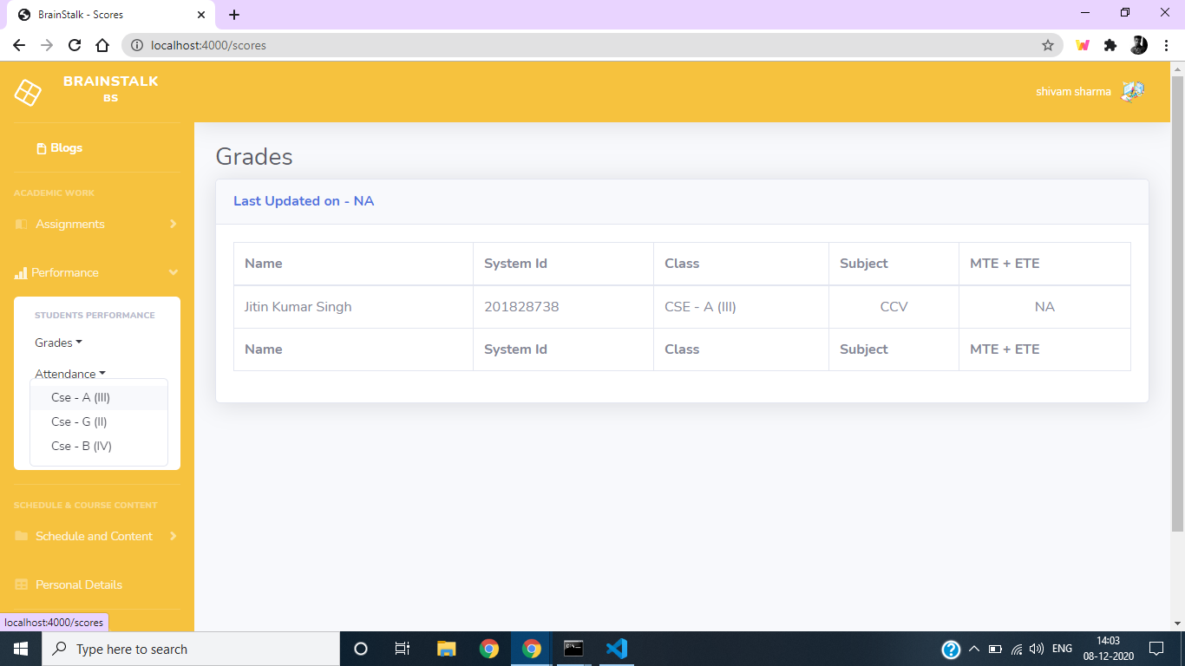

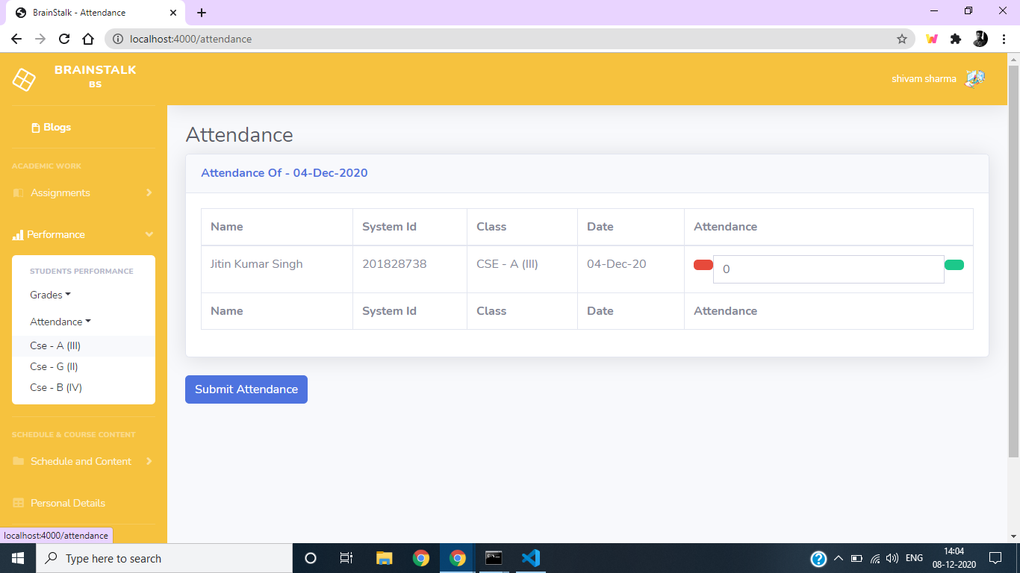

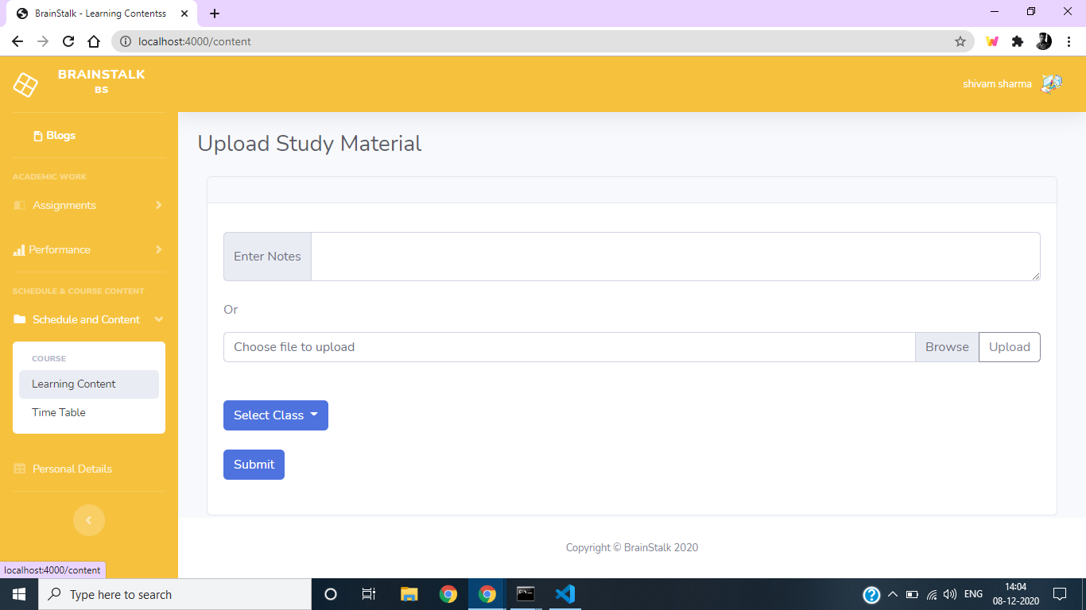

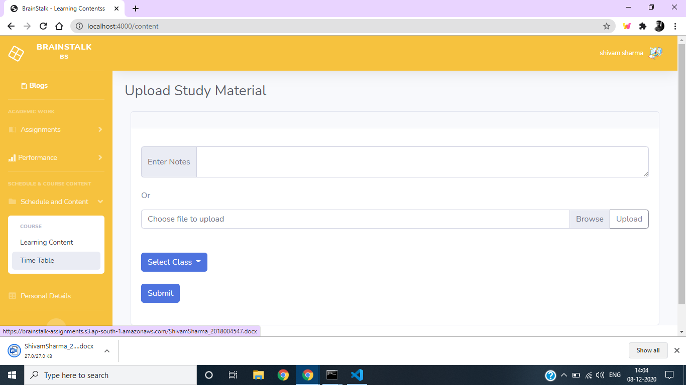

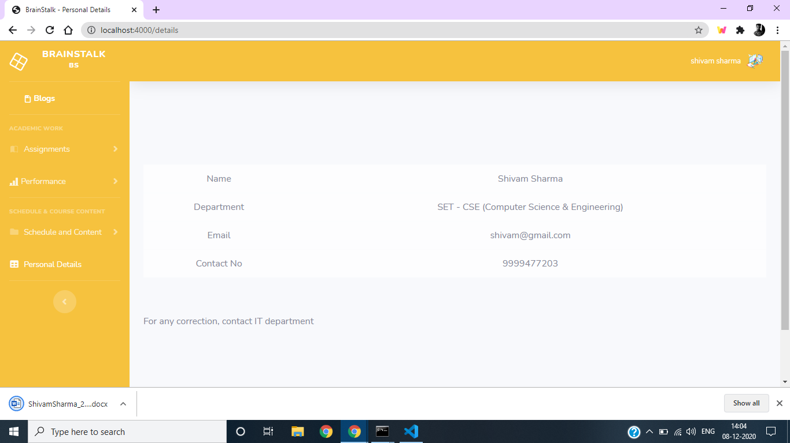

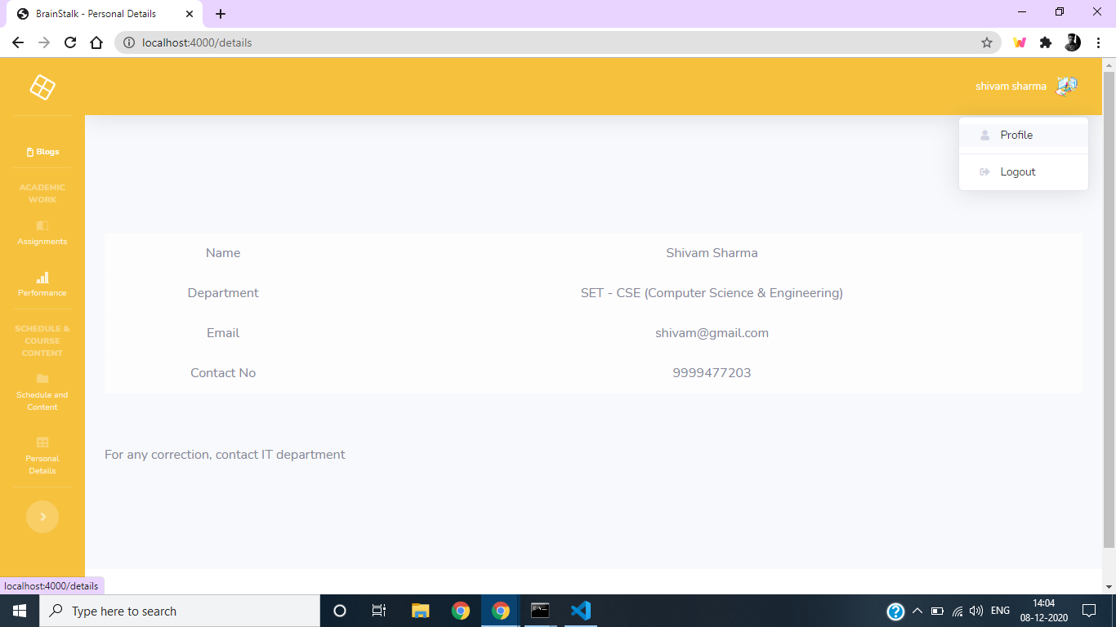

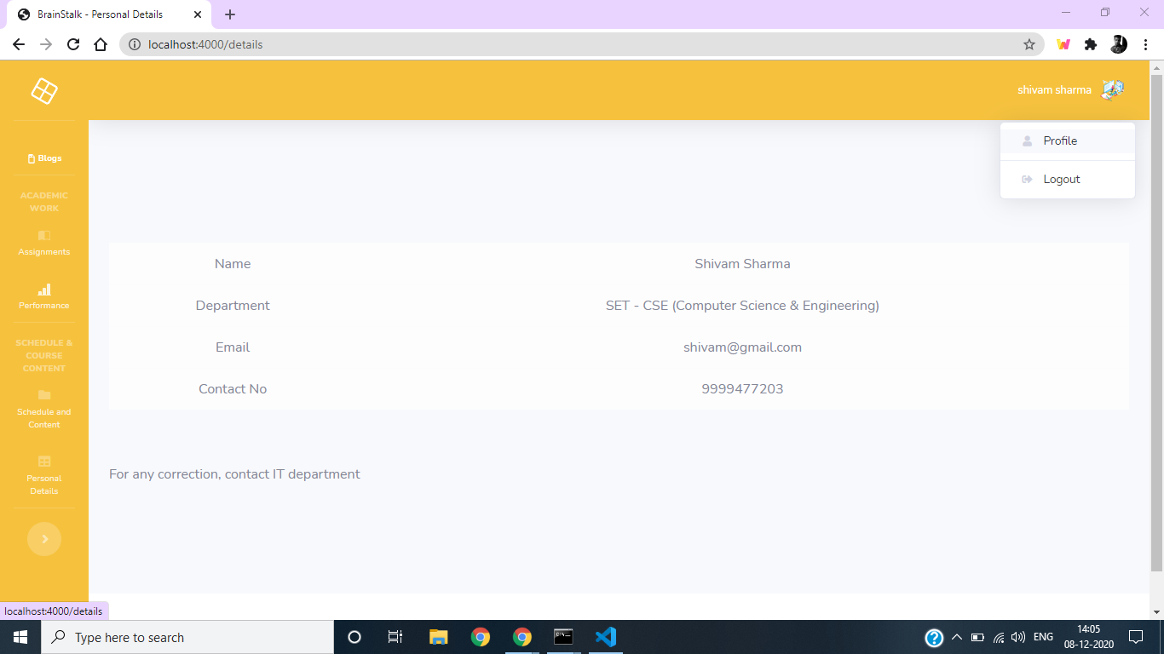

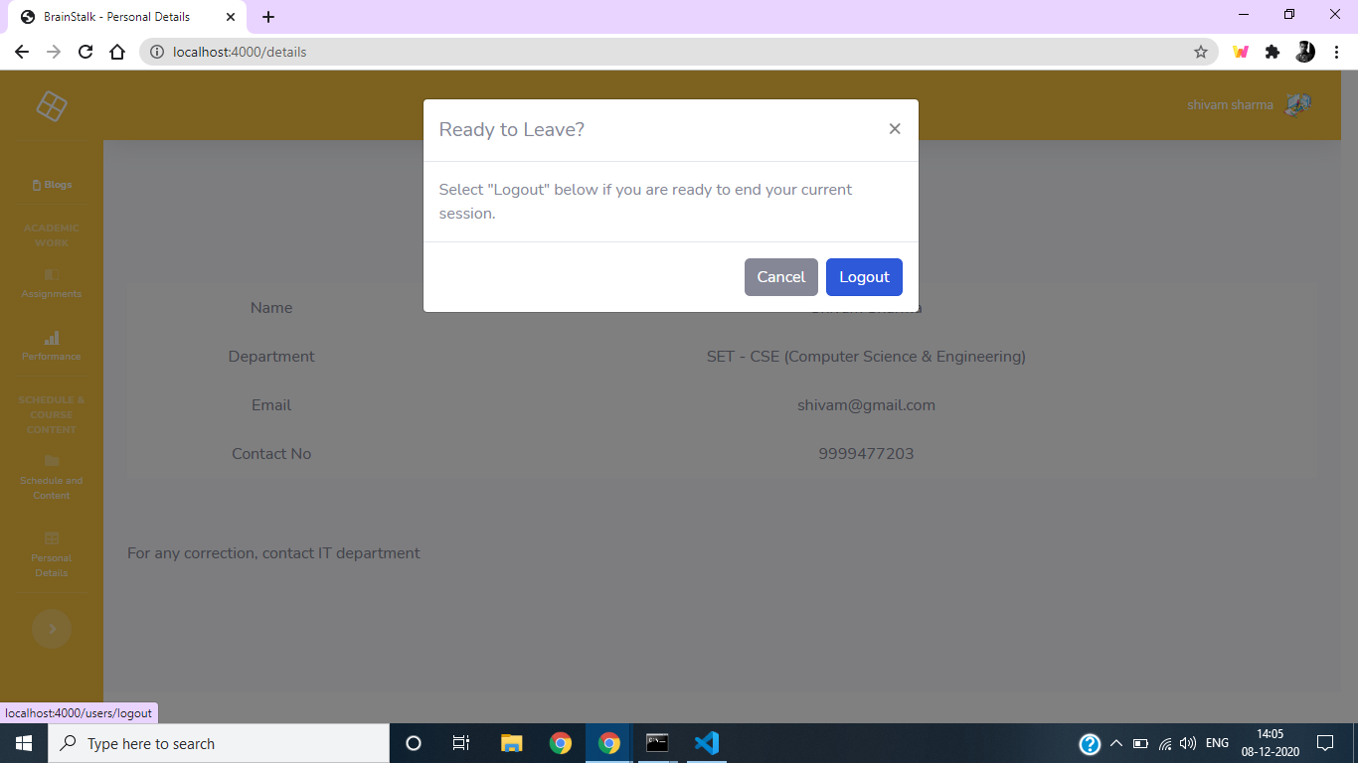

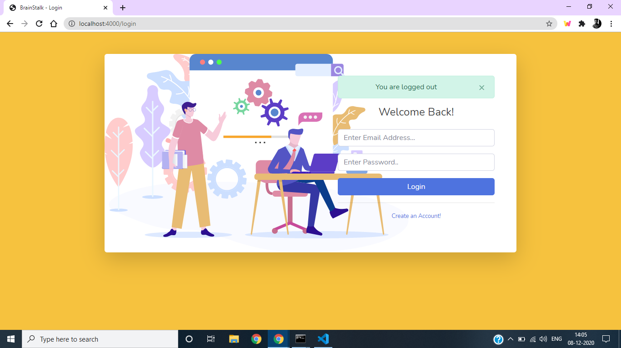

* **Student’s Portal**

